Internship Report
Name: Jean-Luc Twite
Department: IT
Company: ERG Africa Frontier Mine
Reporting Period: Internship.
Main Supervisor: Mr. Raphael Dipa & Mr. Etienne Mwamini.

1. Introduction
This report presents an overview of the knowledge and practical skills I have acquired since I started working with the networking team at ERG Africa Frontier Mine. The objective of this report is to summaries my learning, hands-on experience, and understanding of network infrastructure within erg frontier-mine

Network Concept Learned
3.1 Basic Networking Fundamentals
Understanding how devices communicate over a network over a network using IP addresses.
What is VLAN
A VLAN (Vitual local Area Network) is way to split one physical NETWORK into many separate networks. At ERG Africa we have different VLANs for CCTV, PCs, Readers according to each department
Difference between a LAN and WAN networks.
- LAN (Local Area Network): Used to connect devices within the same site or location
- WAN (Wide Area Network): Used to connect networks across long distances and to the internet

Wiring and testing UTP cables
I have been introduced to fiber optic cables, splicing it. And what it uses for.
I have learned what a switch is and what it is used for on a network
I have learned the difference between an address mac and Ip addresses
Mac addresses: the Mac addresses is the physical address of the device
The IP address is the address we get when accessing a network
I have also learned how to install system from the network
I have been exposed to the ERG network in structure here below is a small design to show the infrastructure.
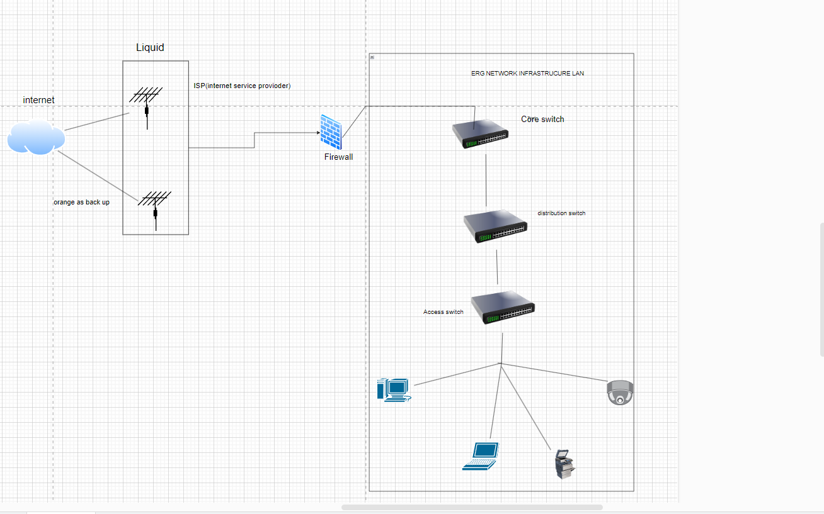

So, we first have our LAN (Local area network) which starts from the core switch, so the core switch is like the network backbone it connects to all distributions and access switches and allows high-speed communication between all systems. On the left we know have the WAN (wide area network) it starts with internet at erg we have two internet service provider we have liquid and Orange, but we prioritize Liquid we only used Orange as a backup when the liquid one is down. Then we have those and antenna that sent request or traffic to our network so because we cannot allow any traffic to our network that were we have now a firewall the firewall is there for security to check which traffic must allow and which aren’t not allow through our network here is my internship based on the network of what i learned please refine it for me and give a more details and clear one.

Conclusion
With the help of the network team I have learn a lot from someone who didn’t have any Hand-on experience when it comes to the network with the team network at erg Africa help me to understand how network work learning first how the wire an ethernet cable which, I Have been explain on how VLAN work looking forward to learn how to configure VLAN on the switch and Mr. dan show me a small overview of how the ERG Africa frontier mine works I have pasted the small copy of the design as I am still with the team network on my journey during my internship. I can’t wait to learn and to face all the challenges coming int the network world

